CIS336: Lab 6 Answer Sheet

Your name Nathan Rivera

## Solution 1:

***~Paste your solution query here~***

select concat(order_id, " ", order_qty) as TotalItems from order_details

where order_id >= 600;

***~Paste your solution query results text here~***

|  |  |  |  |  |  |
| --- | --- | --- | --- | --- | --- |
| 3 | 15 | 00:33:23 | select concat(order_id, " ", order_qty) as TotalItems from order_details where order_id >= 600 LIMIT 0, 1000 | 28 row(s) returned | 0.000 sec / 0.000 sec |

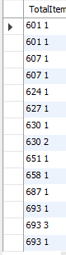

## Solution 2:

***~Paste your solution query here~***

select concat(order_id, " ", order_qty) as TotalItems from order_details

where order_qty > 2;

***~Paste your solution query results text here~***

|  |  |  |  |  |  |
| --- | --- | --- | --- | --- | --- |
| 3 | 17 | 00:35:09 | select concat(order_id, " ", order_qty) as TotalItems from order_details where order_qty > 2 LIMIT 0, 1000 | 1 row(s) returned | 0.000 sec / 0.000 sec |



## Solution 3:

***~Paste your solution query here~***

select concat(orders.order_id, " ", order_details.item_id, " ", items.unit_price, " ", (order_details.order_qty * items.unit_price)) as Itemtotal from orders

join order_details

on orders.order_id = order_details.order_id

join items

on order_details.item_id = items.item_id

where orders.order_id > 400 and orders.order_id < 700;

***~Paste your solution query results text here~***

|  |  |  |  |  |  |
| --- | --- | --- | --- | --- | --- |
| 3 | 23 | 01:03:04 | select concat(orders.order_id, " ",  order_details.item_id, " ",  items.unit_price, " ", (order_details.order_qty * items.unit_price)) as Itemtotal from orders join order_details on orders.order_id = order_details.order_id join items on order_details.item_id = items.item_id where orders.order_id > 400 and orders.order_id < 700 LIMIT 0, 1000 | 23 row(s) returned | 0.000 sec / 0.000 sec |

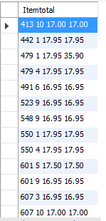

## Solution 4:

***~Paste your solution query here~***

select order_details.order_id, (order_details.order_qty * items.unit_price) as total from order_details

join items

on order_details.item_id = items.item_id

where (order_details.order_qty * items.unit_price) >= 40;

The code is correct however I don’t see a total value for any of the items that are greater than 40. The reason why I know it is correct is that if I change the greater than sign to a less than sign everything shows up. There isn’t anything in the table that would have a value greater than 40 when multiplied by their quantity.

***~Paste your solution query results text here~***

|  |  |  |  |  |  |
| --- | --- | --- | --- | --- | --- |
| 3 | 47 | 01:14:13 | select order_details.order_id, items.unit_price, (order_details.order_qty * items.unit_price) as total from order_details join items on order_details.item_id = items.item_id where concat(order_details.order_qty * items.unit_price) > 40 LIMIT 0, 1000 | 0 row(s) returned | 0.000 sec / 0.000 sec |

## Solution 5:

***~Paste your solution query here~***

select concat(customers.customer_first_name, " ", customers.customer_last_name) as Customer, customers.customer_city, order_details.order_id, (order_details.order_qty * items.unit_price) as total

from orders

join order_details

on orders.order_id = order_details.order_id

join customers

on orders.customer_id = customers.customer_id

join items

on order_details.item_id = items.item_id

where customers.customer_state = "CA"

order by customers.customer_city;

***~Paste your solution query results text here~***

|  |  |  |  |  |  |
| --- | --- | --- | --- | --- | --- |
| 3 | 77 | 01:25:14 | select concat(customers.customer_first_name, " ", customers.customer_last_name) as Customer, customers.customer_city, order_details.order_id, (order_details.order_qty * items.unit_price) as total from orders join order_details on orders.order_id = order_details.order_id join customers on orders.customer_id = customers.customer_id join items on order_details.item_id = items.item_id where customers.customer_state = "CA" order by customers.customer_city LIMIT 0, 1000 | 31 row(s) returned | 0.000 sec / 0.000 sec |



## Solution 6:

***~Paste your solution query here~***

select items.title, sum(order_details.order_qty) as Quantity, sum(items.unit_price) as TotalSales

from order_details

join items

on order_details.item_id = items.item_id

group by items.title

order by sum(items.unit_price) desc;

***~Paste your solution query results text here~***

|  |  |  |  |  |  |
| --- | --- | --- | --- | --- | --- |
| 3 | 227 | 02:12:14 | select items.title, sum(order_details.order_qty) as Quantity, sum(items.unit_price) as TotalSales from order_details join items on order_details.item_id = items.item_id group by items.title order by sum(items.unit_price) desc LIMIT 0, 1000 | 8 row(s) returned | 0.000 sec / 0.000 sec |

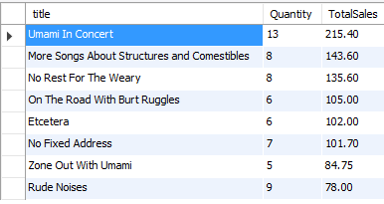

## Solution 7:

***~Paste your solution query here~***

select concat(customers.customer_first_name, " ", customers.customer_last_name) as customer, sum(items.unit_price) as Total

from items

join order_details

on items.item_id = order_details.item_id

join orders

on order_details.order_id = orders.order_id

join customers

on customers.customer_id = orders.customer_id

group by customers.customer_first_name

having sum(items.unit_price) > 50

order by sum(items.unit_price) asc;

***~Paste your solution query results text here~***

|  |  |  |  |  |  |
| --- | --- | --- | --- | --- | --- |
| 3 | 507 | 02:46:58 | select concat(customers.customer_first_name, " ", customers.customer_last_name) as customer, sum(items.unit_price) as Total from items join order_details on items.item_id = order_details.item_id join orders on order_details.order_id = orders.order_id join customers on customers.customer_id = orders.customer_id group by customers.customer_first_name having sum(items.unit_price) > 50 order by sum(items.unit_price)  asc LIMIT 0, 1000 | 7 row(s) returned | 0.016 sec / 0.000 sec |

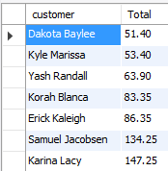

## Solution 8:

***~Paste your solution query here~***

select sum(order_details.order_qty), artists.artist_name

from artists

join items

on items.artist_id = artists.artist_id

join order_details

on order_details.item_id = items.item_id

where order_details.order_qty in

(select order_details.order_qty

from order_details)

group by artists.artist_name;

***~Paste your solution query results text here~***

|  |  |  |  |  |  |
| --- | --- | --- | --- | --- | --- |
| 3 | 8 | 13:04:41 | select sum(order_details.order_qty), artists.artist_name from artists join items on items.artist_id = artists.artist_id join order_details on order_details.item_id = items.item_id where order_details.order_qty in (select order_details.order_qty from order_details) group by artists.artist_name LIMIT 0, 1000 | 6 row(s) returned | 0.000 sec / 0.000 sec |

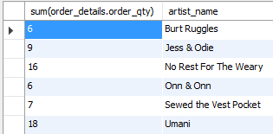

## Solution 9:

***~Paste your solution query here~***

select artists.artist_name, sum(order_details.order_qty * items.unit_price) as Total

from artists

join items

on items.artist_id = artists.artist_id

join order_details

on order_details.item_id = items.item_id

group by artists.artist_name

order by Total desc

;

***~Paste your solution query results text here~***

|  |  |  |  |  |  |
| --- | --- | --- | --- | --- | --- |
| 3 | 44 | 13:09:07 | select artists.artist_name, sum(order_details.order_qty * items.unit_price) as Total from artists join items on items.artist_id = artists.artist_id join order_details on order_details.item_id = items.item_id group by artists.artist_name order by Total desc LIMIT 0, 1000 | 6 row(s) returned | 0.000 sec / 0.000 sec |



## Solution 10:

***~Paste your solution query here~***

select items.title, items.unit_price, round((items.unit_price + (items.unit_price * 0.1)), 2) as Price_increase

from artists

join items

on items.artist_id = artists.artist_id

;

***~Paste your solution query results text here~***

|  |  | **Time** | **Action** | **Message** | **Duration / Fetch** |
| --- | --- | --- | --- | --- | --- |
| 3 | 1 | 15:57:50 | select items.title, items.unit_price, round((items.unit_price + (items.unit_price * 0.1)), 2) as Price_increase from artists join items on items.artist_id = artists.artist_id LIMIT 0, 1000 | 10 row(s) returned | 0.000 sec / 0.000 sec |

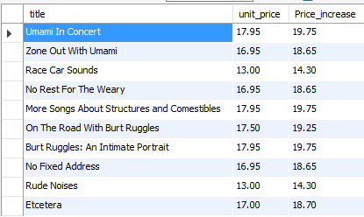

## Solution 11:

***~Paste your solution query here~***

select concat(customers.customer_first_name, " ", customers.customer_last_name) as Customer

from customers

join orders

on orders.customer_id = customers.customer_id

where orders.shipped_date is null

;

I can’t figure out how to do this one. Every time I try and do a subquery the answer always comes up blank.

***~Paste your solution query results text here~***

|  |  |  |  |  |  |
| --- | --- | --- | --- | --- | --- |
| 3 | 170 | 16:09:48 | select concat(customers.customer_first_name, " ", customers.customer_last_name) as Customer from customers join orders on orders.customer_id = customers.customer_id where orders.shipped_date is null LIMIT 0, 1000 | 3 row(s) returned | 0.000 sec / 0.000 sec |

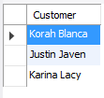

## Solution 12:

***~Paste your solution query here~***

select items.title, sum(order_details.order_qty * items.unit_price) as TotalSales

from order_details

join items

on order_details.item_id = items.item_id

join orders

on orders.order_id = order_details.order_id

join customers

on orders.customer_id = customers.customer_id

where customers.customer_state = "NY"

***~Paste your solution query results text here~***

|  |  |  |  |  |  |
| --- | --- | --- | --- | --- | --- |
| 3 | 184 | 16:14:54 | select items.title, sum(order_details.order_qty * items.unit_price) as TotalSales from order_details join items on order_details.item_id = items.item_id join orders on orders.order_id = order_details.order_id join customers on orders.customer_id = customers.customer_id where customers.customer_state = "NY" LIMIT 0, 1000 | 1 row(s) returned | 0.000 sec / 0.000 sec |

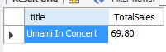

## Solution 13:

***~Paste your solution query here~***

select items.title, artist_name

from items

join artists

on items.artist_id = artists.artist_id

join order_details

on order_details.item_id = items.item_id

join orders

on orders.order_id = order_details.order_id

where not exists

(

select items.item_id

from orders

where order_details.item_id is not null

)

I have tried everythin and all I can get to appear is a blank page.

***~Paste your solution query results text here~***

|  |  |  |  |  |  |
| --- | --- | --- | --- | --- | --- |
| 3 | 319 | 16:35:05 | select items.title, artist_name from items join artists on items.artist_id = artists.artist_id join order_details on order_details.item_id = items.item_id join orders on orders.order_id = order_details.order_id where not exists ( select items.item_id     from orders     where order_details.item_id is not null ) LIMIT 0, 1000 | 0 row(s) returned | 0.000 sec / 0.000 sec |

## Solution 14:

***~Paste your solution query here~***

select orders.order_id, orders.order_date, orders.shipped_date, (order_details.order_qty * items.unit_price) as Total

from orders

join order_details

on orders.order_id = order_details.order_id

join items

on order_details.item_id = items.item_id

join customers

on orders.customer_id = customers.customer_id

where customers.customer_first_name = "Samuel" and customers.customer_last_name = "Jacobsen"

;

***~Paste your solution query results text here~***

|  |  |  |  |  |  |
| --- | --- | --- | --- | --- | --- |
| 3 | 335 | 16:40:23 | select orders.order_id, orders.order_date, orders.shipped_date, (order_details.order_qty * items.unit_price) as Total from orders join order_details on orders.order_id = order_details.order_id join items on order_details.item_id = items.item_id join customers on orders.customer_id = customers.customer_id where customers.customer_first_name = "Samuel" and customers.customer_last_name = "Jacobsen" LIMIT 0, 1000 | 8 row(s) returned | 0.000 sec / 0.000 sec |

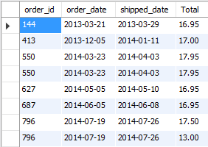

## Solution 15:

***~Paste your solution query here~***

select concat(employees.first_name, " ", employees.last_name) as Employee, sum(order_details.order_qty * items.unit_price) as Total

from employees

join orders

on orders.employee_id = employees.employee_id

join order_details

on orders.order_id = order_details.order_id

join items

on order_details.item_id = items.item_id

group by employees.employee_id;

***~Paste your solution query results text here~***

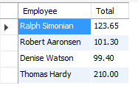

|  |  | **Time** | **Action** | **Message** | **Duration / Fetch** |
| --- | --- | --- | --- | --- | --- |
| 3 | 1 | 16:47:54 | select concat(employees.first_name, " ", employees.last_name) as Employee, sum(order_details.order_qty * items.unit_price) as Total from employees join orders on orders.employee_id = employees.employee_id join order_details on orders.order_id = order_details.order_id join items on order_details.item_id = items.item_id group by employees.employee_id LIMIT 0, 1000 | 4 row(s) returned | 0.000 sec / 0.000 sec |